Tropical cyclone **storm surge**, part of climada module **tropical cyclone** 22 May 2017

Formerly until 20151224 a module <https://github.com/davidnbresch/climada_module_tc_surge>

[david.bresch@gmail.com](mailto:david.bresch@gmail.com)

Needs the climada module elevation models[1]

This module implements a raw version of a tropical cyclone storm surge model[2]. It’s based on climada’s core tropical cyclone (TC) module. Hence in order to run tc_surge, make sure you’ve made yourself familiar (to some extent at least) with the core climada tropical cyclone hazard module. Please

recall that climada stores the hazard information for each event_i at each centroid_j as hazard.arr(event_i,centroid_j). Hence any climada hazard event set (stored in a structure hazard) contains all hazard event footprints for a given region (i.e. all tropical cyclones in the North Atlantic basin). Further to that, probabilistic hazard events can be generated and hence a full probabilistic hazard event set contains not only the historic events, but also a full set of probabilistic (storm) events for a given hazard in a given region. See the core climada manual for details.

In essence, tc_surge infers a proxy storm surge height (measured in m above terrain, not MSL[3]) from the maximum windspeed (peak gust in in m/s) for each TC event at each centroid, i.e. it takes hazard.arr(event_i,centroid_j) and converts the maximum windspeed into a proxy surge height. It then uses a global bathymetry (and topography) dataset[4] to infer land surface height at each centroid and hence calculates the remaining surge given the height of any given centroid.

The relation between maximum windspeed and surge height is implemented in the code tc_surge_hazard_create, where

surge height [m] = max( f(wind speed [m/s]) - elevation [m], 0)

where you find f(wind speed) documented further below and the elevation is the elevation of the centroid, inferred from the bathymetry data.

We do present a crude approach here, but given the many other uncertainties in the full economics of climate adaptation calculations, the method provides good enough a basis for the intended purpose.

Please use **tc_surge_TEST** to test this module. The code

tc_surge_hazard_create creates a storm surge (TS) hazard event,

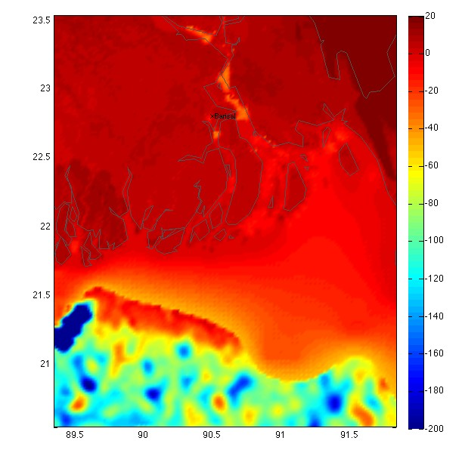based on an existing tropical cyclone (TC) hazard event set (see e.g. climada_tc_hazard_set)

The high-resolution bathymetry dataset (ETOPO1) for a region in Bangladesh (the city of Barisal is denoted). Note the very high resolution of the elevation information.

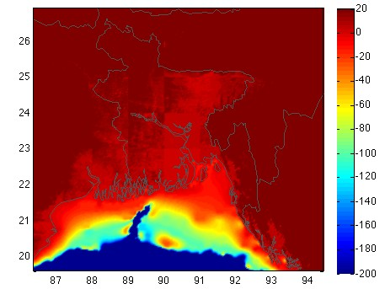For comparison, the mid-resolution bathymetry dataset (ETOPO2) for the same region (a bit larger area shown). Note the kind of ‘tiles’ in the land area, leading to artificial ‘steps’ in elevation of a few decimeters… Hence the use of ETOPO1 is highly recommended.

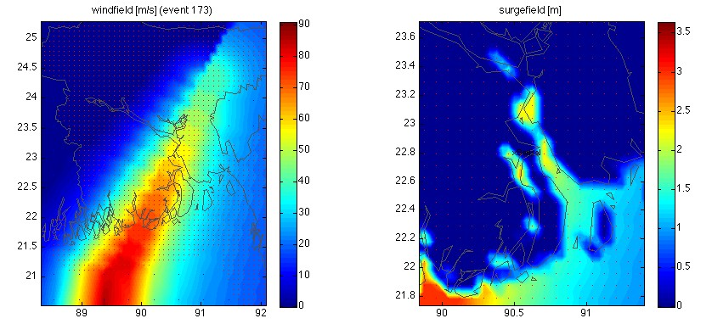

Comparison of maximum gust wind field (left) and resulting surge height field (right, zoomed in, city of Barisal marked) for the strongest recent event in Bangladesh (Nov 2007).

# Wind speed surge height relationship

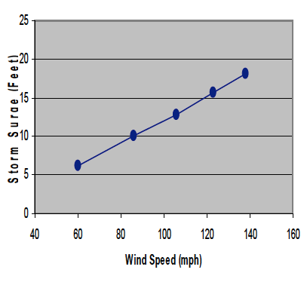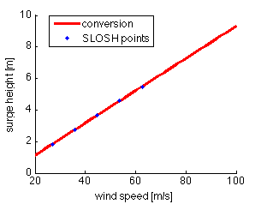

The simple linear relationship between wind speed and surge height[5]. Simple conversion in SI units[6] reveals a function like

surge height [m] = a * (v-v0) + b with a=0.1023 [m/ms-1], b=1.8288 [m],

v0=26.8224 [m/s], and v the 1-min surface sustained wind in m/s. Not applicable to wind speeds much lower than 20 m/s. The wind speed is the 1-min surface sustained wind (usually expressed in knots [kt], hence the mph looks a bit strange in the graph).

We kept the parameters as cited above, well aware of a certain level of ‘mock precision’.

# Appendix: Output of the TEST run for Bangladesh

If you run, tc_surge_TEST you get (colors might be different):

First, we obtain the full historic tropical cyclone dataset:

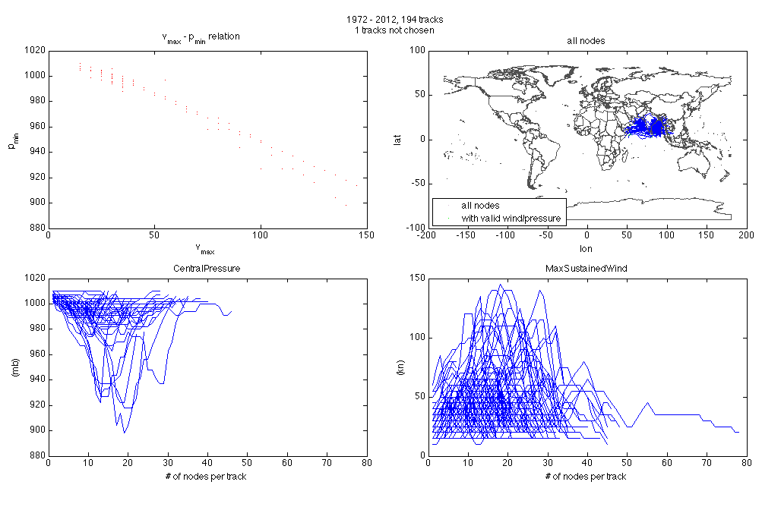

Second, we establish the wind speed decay relationship based on all historical events:

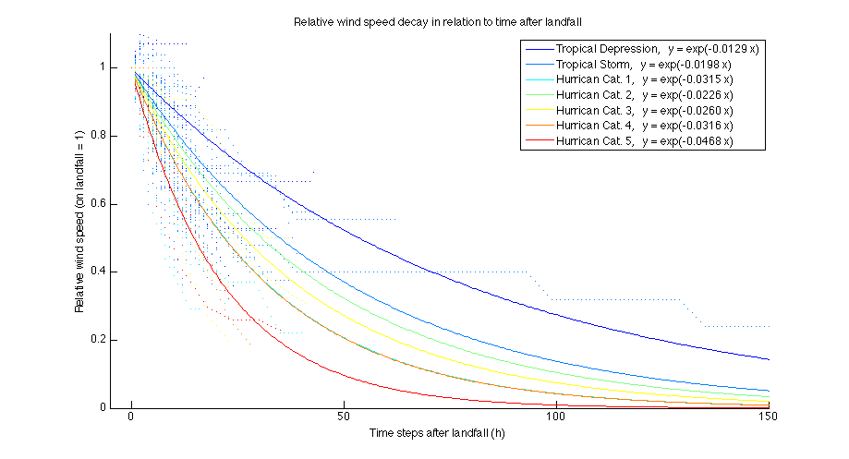

Third, we generate the probabilistic tracks:

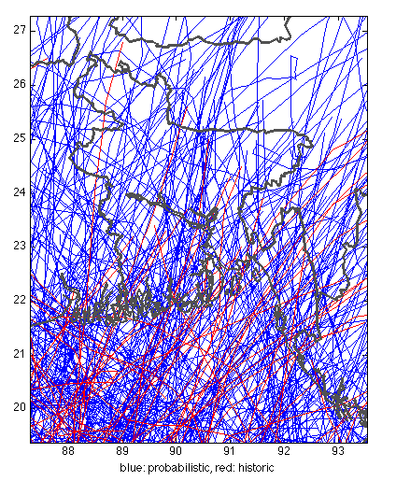

Fourth, we apply the decay to correct for probabilistic storms to show the same decay relationship as the historic events (correct for probabilistic storms be ‘moved’ inland with unrealistic ‘open water’ windspeeds):

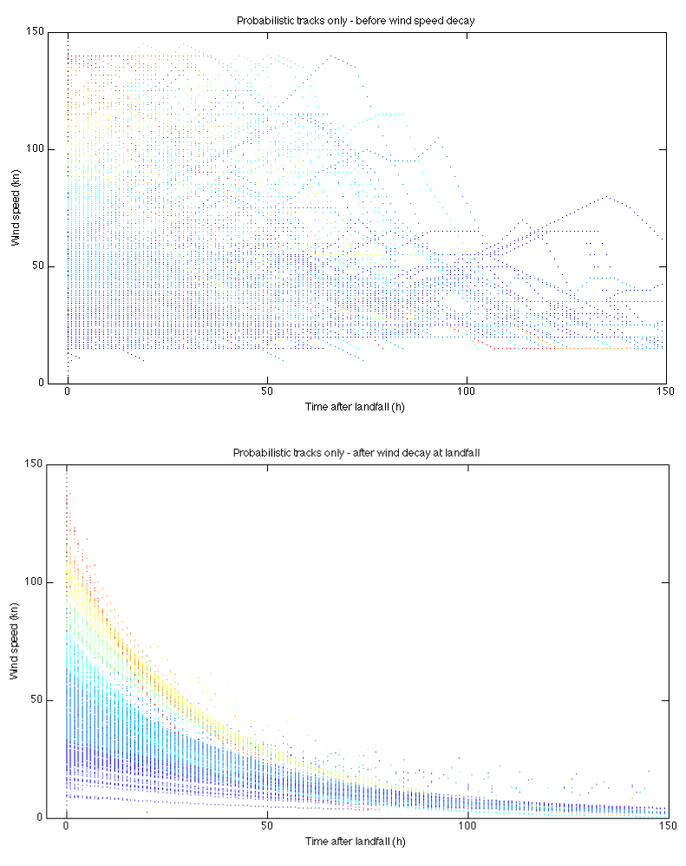

We then create the wind fields for all events (both historic and probabilistic). Not shown.

Fifth, we obtain the bathymetry:

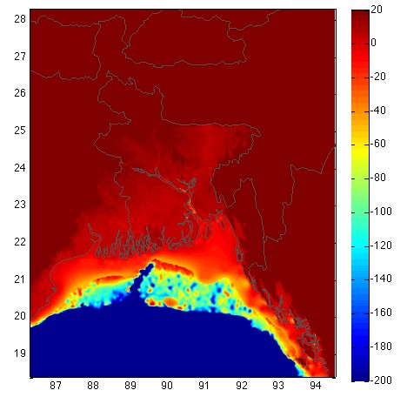

Sixth, convert event-by-event into storm surge footprint:

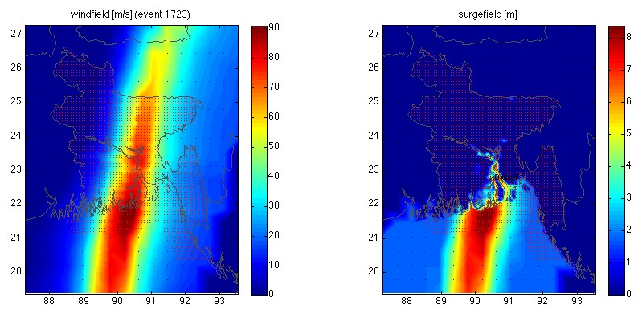

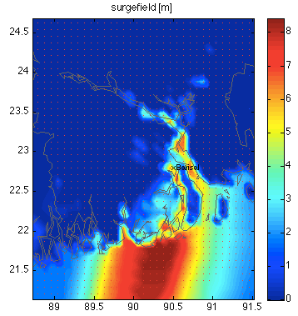Seventh (and last), the maximum storm surge height obtained in the whole basin (and a zoom into the surge height above right):

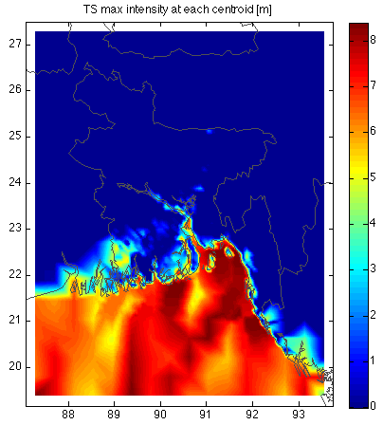

Appendix – 3D plot

See tc_surge_plot_3d for 3D plots of surge height, with the surge level ‘overshadowing’ the elevation:

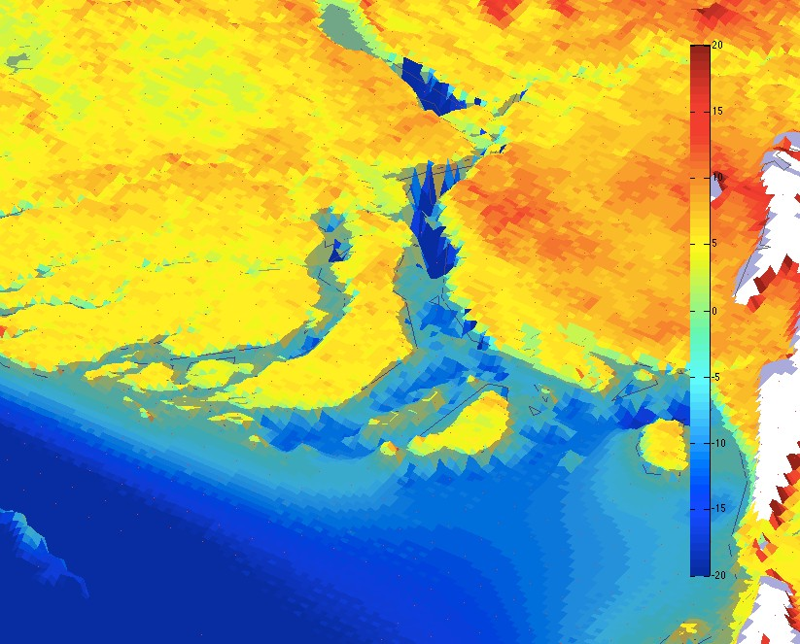

The bathymetry (light green and blue), topography (yellow to red) and the surge as semi-translucent surface (in a kind of light blue) to indicate the extent of surge (the maximum surge height of all events, not a particular one). 1 voxel 1’ x 1’ or approx. 1.7km x 1.7km, area approx. 3km2. Tiny red dots indicate centroids, black line the seashore.

1. <https://github.com/davidnbresch/climada_module_elevation_models>
2. Please note that a similar module exists for torrential rain, named tc_rain
3. This convention is most useful, as the damage-relevant surge height is the height of the surge at each asset’s location, i.e. the centroid. This way, the elevation oft the centroid does not need to be known at the time of damage calculation (in code climada), but only at the time oft the generation oft the storm surge hazard event set.
4. It uses ETOPO dataset, see <http://www.ngdc.noaa.gov/mgg/global/global.html> and the readme files in .../etopo/data/ (get <https://github.com/davidnbresch/climada_module_elevation_models>)
5. Liming Xu, 2010: A SIMPLE COASTLINE STORM SURGE MODEL BASED ON PRE-RUN

   SLOSH OUTPUTS. 29th Conference on Hurricanes and Tropical Meteorology, 10–14 May 2010, Tucson, Arizona.
6. 1 mph = 0.44704 m/s, 1 foot = 0.3048 m